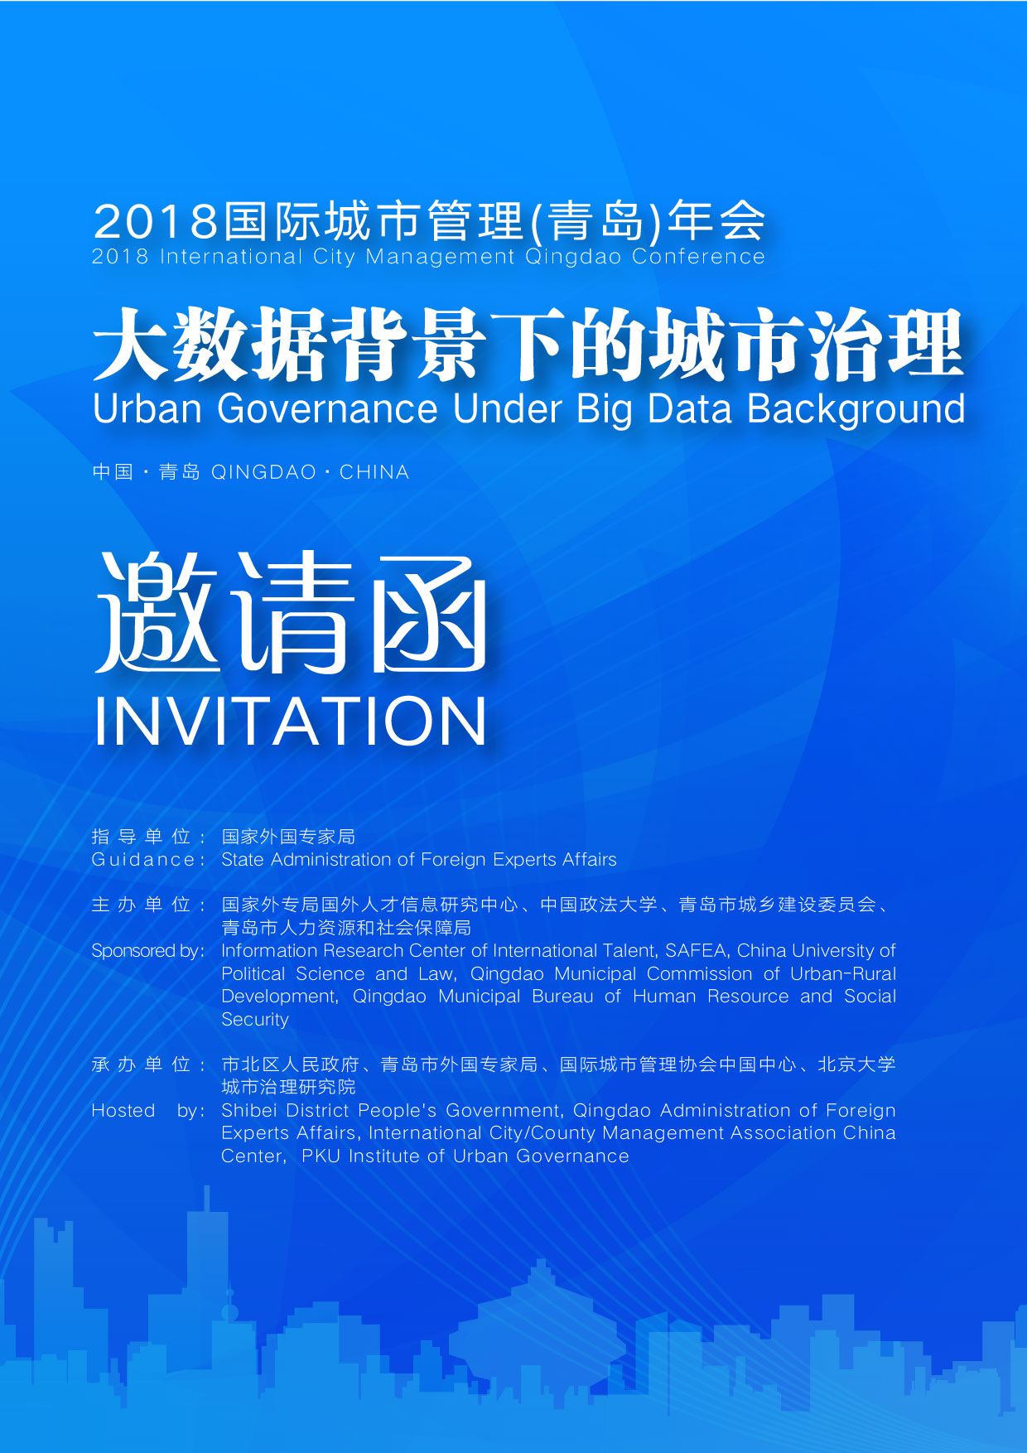
尊敬的______先生/女士：

尊敬的 先生/女士：
您好！
“2018国际城市管理（青岛）年会”定于2018年4月10日—13日在青岛举行。主题为“大数据背景下的城市治理”。本次年会由国家外专局国外人才信息研究中心、中国政法大学、青岛市城乡建设委员会、青岛市人力资源和社会保障局主办，市北区人民政府、青岛市外国专家局、国际城市管理协会中国中心、北京大学城市治理研究院承办，新华社国家高端智库青岛中心提供综合性智库服务。
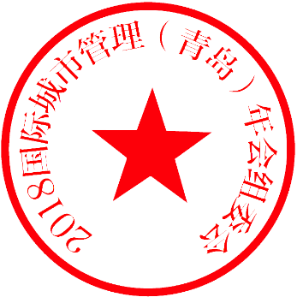
随着中国城市化进程的不断深入发展，城市治理已经成为国家治理体系和治理能力现代化建设的焦点问题。习近平总书记指出，要强化智能化管理，提高城市管理标准，更多运用互联网、大数据等信息技术手段，提高城市科学化、精细化、智能化管理水平。届时，海内外从事城市治理的经济学家、企业代表与专家学者将齐聚一堂，共话当今大数据背景下城市治理面临的机遇和挑战，探索现代化城市发展路径和方法，进而为青岛提高城市管理水平建言献策。
我们诚挚邀请您拨冗出席，并期待分享您的远见卓识！
顺颂商祺！
2018国际城市管理（青岛）年会组委会
2018年3月
2018国际城市管理（青岛）年会日程表
日期 | 时间 | 主题内容 | 地点
4月10日 | 12:00-23:00 | 嘉宾报到 | 黄海饭店
4月11日 | 全天 | 嘉宾报到及参观 | 黄海饭店
4月12日 | 09:00-12:10 | 2018国际城市管理（青岛）年会开幕式暨主旨演讲 | 黄海饭店
4月12日 | 14:00-16:45 | 平行论坛一：城市生长力与城市治理品牌建设 | 黄海饭店
4月12日 | 14:00-16:45 | 平行论坛二：智慧社区与城市治理 | 黄海饭店
4月12日 | 14:00-16:45 | 平行论坛三：智能交通与城市发展 | 黄海饭店
4月12日 | 14:00-16:45 | 平行论坛四：大数据与全球城市治理 | 黄海饭店
4月12日 | 17:00-17:30 | 2018国际城市管理（青岛）年会闭幕式 | 黄海饭店

联系人：宋昕翼 联系电话：13906397851 E–mail : ioicsxy@126.com

March 2018
Dear Sir/Madam______,
I hope this letter finds you well.
The 2018 International City Management Qingdao Conference is scheduled to be held in Qingdao from April 10th to 13th, 2018. The theme is Urban Governance in the Background of Big Data. The conference is hosted by the Information Research Center of International Talent,SAFEA, the China University of Political Science and Law, the Qingdao Municipal Commission of Urban-Rural Development and the Qingdao Municipal Bureau of Human Resource and Social Security. It is being undertaken by the Shibei District People's Government, the Qingdao Administration of Foreign Experts Affairs, the International City/County Management Association China Center and the PKU Institute of Urban Governance, with comprehensive think tank services provided by the Xinhua News Agency State High-end Think Tank Qingdao Center.
Urbanization is undergoing its significant development in China, and urban governance has become the focus of the national governance system and governance capacity modernization. The General Secretary Xi Jinping pointed out that we are supposed to strengthen intelligent management, improve urban management standards, and make more use of information technologies, such as the Internet and big data, to make urban management more scientific, sophisticated and intelligent. On this occasion, economists, business representatives, experts and scholars engaged in urban governance at home and abroad will gather together to discuss the opportunities and challenges faced by urban governance in the context of today’s big data, explore the paths and methods of modern urban development, and then provide suggestions for Qingdao to improve its city management.
We sincerely invite you to take the time to attend and share your foresight and knowledge!
Best regards,
Organizing Committee of 2018 International City Management Qingdao Conference

Schedule of 2018 International City Management Qingdao Conferenc
Date | Time | Contents | Venue
April 10 | 12:00-23:00 | Check-in | Huanghai Hotel
April 11 | Full day | Check-in and visit | Huanghai Hotel
April 12 | 09:00-12:10 | Opening Ceremony and Keynote Speech of 2018 International City Management Qingdao Conference | Huanghai Hotel
April 12 | 14:00-16:45 | Parallel Forum I:  Urban Growth and Urban Governance Brand Building | Huanghai Hotel
April 12 | 14:00-16:45 | Parallel Forum II:  Smart Community and Urban Governance | Huanghai Hotel
April 12 | 14:00-16:45 | Parallel Forum III:  Intelligent Transportation and Urban Development | Huanghai Hotel
April 12 | 14:00-16:45 | Parallel Forum IV:  Big Data and Global Urban Governance | Huanghai Hotel
April 12 | 17:00-17:30 | Closing Ceremony of the 2018 International City Management Qingdao Conference | Huanghai Hotel
Contact Person : Song Xinyi Contact Number: 13906397851 E-mail: ioicsxy@126.com

